**(Annex 5)**

***(Please delete this page before submitting)***

Moonshot Research and Development Program for Agriculture, Forestry and Fisheries

Call for Project Managers Application Guidelines

Project Plan Proposal

(Including examples of description and points to note)

|  |
| --- |
| * Please use the prescribed form (Word file) and never modify the form. * Please strictly adhere to the number of characters for items that designate a character limit. Even if there are no restrictions of the number of characters for items, please try to write concise, clear, and easy-to-understand descriptions so that the number of pages is not excessive. * Please delete and submit forms that do not apply. * In principle, please write in **Arial** typeface.   **Please delete the blue letters and unnecessary pages from this document and submit it as a research project proposal**. Please do not forget to upload the created form after entering the required information into the cross-ministerial research and development management system (e-Rad). |

March 2023

***(Please delete this page before submitting)***

* The project plan proposal has the following structure. In the section of the form that says [applicable research project only], please fill in only the applicable research project and submit it.
* In principle, the project period permitted at the time of adoption is from FY2023 to FY2024, but please prepare a project plan for the entire project period (up to FY2029) necessary for the proposed project in this proposal. In FY2024, the Council for Science, Technology, and Innovation (CSTI) will decide whether to continue or terminate research and development (of the entire program) after FY2025. If it is decided to continue the program, it will be extended up to FY2029.
* When creating a project plan proposal, please follow the “examples of description and points to note” written in blue in the form. Please delete all blue letters when submitting.
* When creating 7-(2), 7-(3), 7-(4) and 8, please fill in the details in the Excel file Attachment 5-2 “Proposal Preparation Form” and attach an image to this form.

Structure of Project Plan Proposal for Moonshot Research and Development Program for Agriculture, Forestry and Fisheries

|  |  |
| --- | --- |
| Cover | [required] |
| 1. Project Manager (PM) | [required] |
| 2. Scenario | [required] |
| 3. Key points of the project plan | [required] |
| 4. Composition of the research group | [required] |
| 5. Implementation system chart of the project plan (Research group relationship chart) | [required] |
| 6. Outline chart of project plan | [required] |
| 7. Project plan | [required] |
| 8. Information on Participating Institutions, and others | [required] |
| 9. Participating institution's efforts toward intellectual property, and others | [required] |
| 10. Accounting operation system | [required] |
| 11. Participation of young researchers | [required] |
| 12. Promotion of work-life balance | [required] |
| 13. Conflict of Interest | [required] |
| 14. Statement of reasons for utilizing the research management administrative body | [applicable research project only] |
| 15. Agreement/understanding | [required] |

**Project Plan Proposal Form (Annex 5)**

**“Moonshot Research and Development Program**

**for Agriculture, Forestry and Fisheries”**

**Project Plan Proposal**

**Moonshot Goal 5**

“Creation of food supply industry that enables sustainable global food supply with no overburden nor waste by full use of unutilized biological resources by 2050”

**Research and Development Target**

“By 2050, develop solutions that eliminate food loss and waste and promote healthy and environmentally friendly reasonable food consumption”

**Field selection**

|  |  |
| --- | --- |
|  | Humanities/Social Sciences field |
|  | Natural sciences field |
|  | Includes both humanities/social sciences field and natural sciences field |

*Please select the field of the proposed research project. The themes for the humanities/social sciences fields and natural sciences fields in this public call are as follows. If it is an innovative and challenging theme to reduce food loss, it is possible to propose beyond the following themes.

(Public call theme in the fields of humanities and social sciences)

(i) Investigative research to comprehensively grasp where and how much food loss is generated

(ii) Investigative research to build a social system that is conscious of food loss and reduces its generation

(Public call theme in the fields of natural sciences)

(iii) Research to produce tasty foods using surplus agricultural products and unused foods, and others

(iv) Development of manufacturing technology for processed foods using surplus agricultural products and unused foods, and others

(v) Development of innovative long-term food storage technology

**Application information**

|  |  |
| --- | --- |
| Project name |  |
| Research consortium name |  |
| Representative institution name |  |
| Project Manager name/position |  |
| Research period | 2023-202X (X years) (*1) |

|  |  |  |  |  |  |  |  |
| --- | --- | --- | --- | --- | --- | --- | --- |
| **Estimated necessary expenses (total amount) (*2) (unit: million yen)** | | | | | | | |
| FY2023 | FY 2024 | FY 2025 | FY 2026 | FY 2027 | FY 2028 | FY 2029 | Total |
|  |  |  |  |  |  |  |  |

(Note *1) Enter the research period necessary for the proposed project.

(Note *2) Enter the estimated amount of necessary expenses (total amount) for each fiscal year.

1. **Project Manager (PM)** ***1 sheet of A4 paper***
2. **Project manager information**

|  |  |
| --- | --- |
| Full name |  |
| Affiliation/Position |  |
| Academic degree |  |
| Main careers and research content |  |
| Effort (%) (*1) |  |

(Note *1) Please describe your "effort" for this project. "Effort" is the allocation ratio (%) of the time required to carry out each research activity, and others, out of the total annual work hours (substantial total work hours including educational activities, and others, in addition to time for research activities). Further, if this application is adopted, the effort at that time will be decided again and registered in e-Rad.

1. **Eligibility as PM of this project**

* Please fill in the following points.

・To promote cutting-edge research and development, have a wide range of human networks of related researchers in Japan and overseas and specialized knowledge.

・Have management and leadership skills such as constructing an optimal R&D system and flexibly reviewing the system according to progress.

1. **Policy towards management implementation of research and development projects**

* Please write down the policy for managing the proposed R&D project considering the applicant's past research career and management experience. When filling out the form, please also indicate what kind of efforts you plan to make regarding intellectual property management and research data management.

1. **Major research papers, books, and acquisition of patents**

|  |  |
| --- | --- |
| Main research papers, books, patents (up to 5 recent important ones) | Relevance (*2) |
|  |  |
|  |  |
|  |  |
|  |  |
|  |  |

(Note *2) If there is a relationship with the contents of this proposal, please put a circle in the column of “Relevance.”

1. **Scenario** ***Required 1 sheet of A4 paper***

**Scenario leading up to the achievement of the 2050 Moonshot Goal**

1. **Scenario leading up to the achievement of the 2050 Moonshot Goal**

* Please describe the scenario from now until the achievement of Moonshot Goal 5 in 2050, including the target year and achievement targets.

・In the scenario up to 2050, please fill in the development and demonstration of prototypes aimed at during the project period from 2023 to 2030, and the outlook for practical application, commercialization, and popularization from 2030 to 2050 after the end of the project separately.

・Compared to conventional research and development, please indicate that the proposed research content is based on bolder ideas and is more challenging, and that it is innovative and expected to have a major impact on future industry and society.

・Please write so that you can clearly present a valid scenario (success hypothesis) from the technical viewpoint and the viewpoint of social implementation including the division of roles between the public and private sectors, to achieve the 2050 goal.

・Please indicate that the content of the proposal brings together top-level research and development capabilities, knowledge, and ideas, regardless of whether they are from Japan or overseas.

・Please describe your efforts regarding Ethical, Legal and Social Issues (ELSI) to accelerate research and development and promote social implementation. Also, if you are considering cross-disciplinary efforts such as mathematical science, please fill in.

1. **Socio-economic impact when Moonshot Goals are achieved**

* Please fill in the social and economic impact when Moonshot Goal 5 is achieved by your research efforts, including background data.

1. **Key points of the project plan　 *Required 1 sheet of A4 paper***

* Based on the “scenario” leading up to the achievement of Moonshot Goal 5 in 2050 (described in 2.), please provide an outline of the project plan from FY2023 to FY2029 at the longest.

* Please fill in each item concisely and strictly adhere to the number of characters.

|  |  |
| --- | --- |
| i) Technical problem to be solved (outline) | *(Strictly adhere to within 100 characters)* |
|  | |

|  |  |
| --- | --- |
| ii) Achievement goals of the project plan (outline) | *(Strictly adhere to within 200 characters)* |
|  | |

|  |  |
| --- | --- |
| iii) Contents of the project plan (outline) | *(Strictly adhere to within 100 characters)* |
|  | |

|  |  |
| --- | --- |
| iv) Technical superiority | *(Strictly adhere to within 100 characters)* |
|  | |

* Please describe an overview of the scientific evidence, technology, and others that will serve as a breakthrough to realize achievement goals to be filled in 7-(1)-ii) of this proposal “Details of implementation and achievement goals of the project plan.”

|  |  |
| --- | --- |
| v) Exit strategy of the proposed project plan (outline) | *(Strictly adhere to within 100 characters)* |
|  | |

1. **Composition of the research group (*1)　 *Required***

**[Representative organization]**

Name of research institution: XX Faculty, XX University

Division of Roles: Overall supervision and coordination as a representative research institute. Conducting analysis of … and development of … technology.

Providing developed ... research results such as XX technology, and others to participating institutions, and publishing them nationwide on the website, and so on.

**[Collaborative research institution]**

Name of research institution: XX Examination Station XX Branch, XX Prefecture

Division of Roles: Based on the information analyzed by XX University ... it will develop an evaluation method for ... and conduct a field survey of … and develop technology for ….

Name of research institution: (National Institutional Corporation) XX Research Center, XX Organization

Division of Roles: Based on the research information, evaluation methods, and improvement of the prototypes of each participating institution, a manual will be created and distributed.

**[Cooperating organizations] (*2)**

(Research) Institution name: XXXX Co., Ltd.

Division of Roles: Evaluate ... of the ... developed by this research project toward practical application and commercialization.

(Note *1) Please write so that it is clear what kind of research group will be formed and how the research will proceed. Please list all the institutions that you plan to participate in (including cooperating organizations).

(Note *2) A cooperating organization is a third party necessary for carrying out a research project. Cooperating organizations are not members of the consortium and cannot receive research funding directly. For details, please refer to (6) of 3 of the Application Guidelines.

1. **Implementation system chart of the project plan (Research group relationship chart) *Required 1 sheet of A4 paper***

|  |
| --- |
|  |

* For each research institution, and others, fill in the location of the research (prefecture name, country name if overseas) and the details of the project plan, i.e., research items filled in the table of 7 (2) “Project structure and annual plan” of this proposal.

* If there is a research institution, and others, (cooperating organization) that cooperates with the implementation of the project without being entrusted with the commissioned research of this project, please fill in so that it is clearly understood.

Entry example: XXXX Co., Ltd. (cooperating organization)

1. **Outline chart of project plan *Required 1 sheet of A4 paper (both vertical and horizontal are acceptable)***

|  |
| --- |
|  |

* Please attach diagrams, and others to make the understanding this project plan ease.

1. **Project plan** ***Required***
2. **Specific contents of the project plan**
   1. **Technical issues to be solved**

* Please write in detail the content filled in “i) Technical problem to be solved (outline)” in “3. Key points of the project plan” in this proposal.

* 1. **Implementation details and achievement goals of the project plan**

**[Overall research group]**

**Implementation details**

FY2023

FY2024 (External parties’ evaluation)

FY2025 - FY2029

* Fill in summarizing for 5 years

**Achievement goals**

FY2023

FY2024 (External parties’ evaluation)

FY2025 - FY2029

* Fill in summarizing for 5 years

* 1. **Project exit strategy**

* Please write in detail the contents of "v) Exit strategy of the proposed project plan (outline)" in "3. Key points of the project plan" of this proposal.”

* Please write down what kind of performance, specifications, and costs should be equipped for the prototypes to be developed by 2030, and what kind of social and economic impact you think will be brought about if they are achieved.

<Points to note when filling out the implementation details of the project plan>

In line with Moonshot Goal 5 and the research and development concept created by the Ministry of Agriculture, Forestry and Fisheries, regarding the project plan to be implemented for the achievement goals described in (1) fill the details what you wrote in "iii) Contents of the project plan (outline)" of "3. Key points of the project plan” in this proposal" in this proposal.

For effective and efficient efforts through international collaboration, please fill in the contents clearly.

Please describe that the goals and contents of the research and development project is based on bolder ideas and is more challenging compared to conventional one, and that it is innovative and expected to have a major impact on future industry and society.

Please describe that the content of the proposal brings together top-level research and development capabilities, knowledge, and ideas, regardless of whether they are from Japan or overseas.

Particularly, please describe in an easy-to-understand manner the content and path to acquisition of scientific evidence, technology, and others that will serve as a breakthrough to achieve your goals.

Please describe in detail how the research institutions participating in the research group will collaborate and how individual research subjects will produce synergistic effects.

In addition, if there are research institutions, and others (cooperating institutions) that cooperate in the implementation of the R&D project, how will the research institutions participating in the research group and the cooperating institutions specifically cooperate and demonstrate synergy? Please also fill in.

<Points to note when filling achievement goals for the project plan>

In accordance with Moonshot Goal 5 and the research and development concept created by the Ministry of Agriculture, Forestry and Fisheries, in the scenario up to 2050, regarding the achievement goals from FY2023 to the longest of FY2029, please describe the details of the contents filled in “ii) Objectives of the project plan (outline)" of "3. Key points of the project plan" of this proposal.

Please describe the achievement goals that you aim by fiscal 2029 at the longest through this project and other methods, using as many specific and quantitative expressions as possible. (For example; " ... is possible.", "It must be ... type.", "For ..., it must be ... or more.", "We will do ... about ... or more.")

1. **Constitution and annual plan of the project**

Please fill in the content of the implementation details and the achievement goals entered in (1) above in an easy-to-understand manner for each fiscal year and for each institution participating in the research group (representative institution, collaborative research institution, and cooperating institution).

*\*Please fill in up to 2029 at the longest.*

**Copy and paste here the sheet "7-(2)" in the excel file "Proposal Form"**

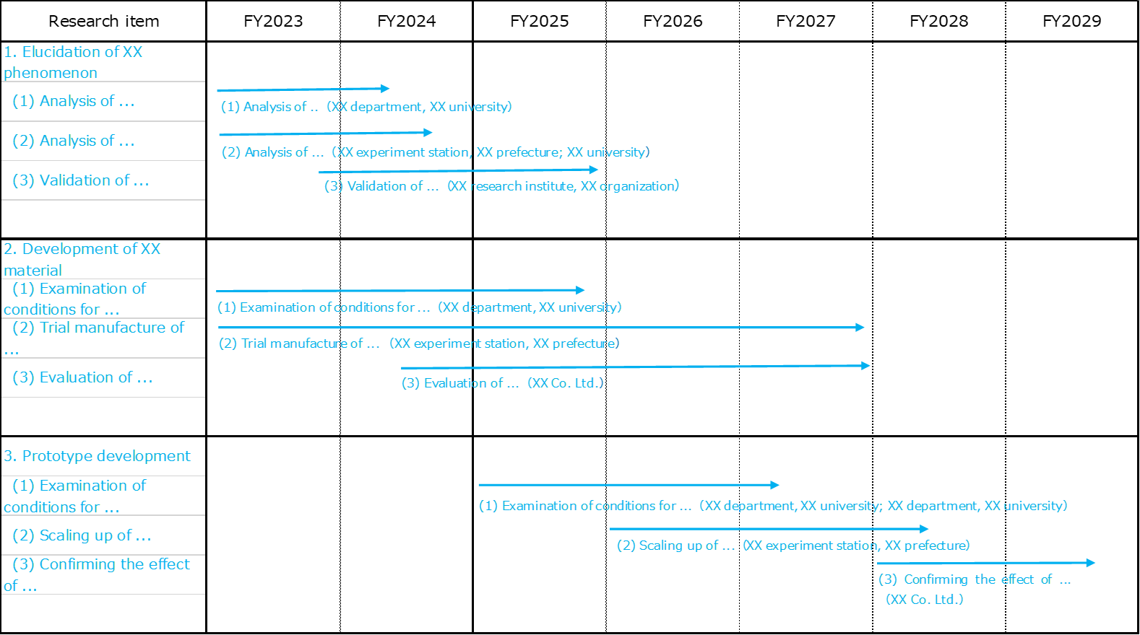

* Please delete the image above that is currently pasted.

1. **Performance, and others of research and development**
2. R&D funded by public funds currently being implemented or applied for

* Please fill in the name of funding system, research project name, research period, research expenses the amount, and differences and relevance to the proposed project regarding the research and development (funded by national competitive research funds and other research grant systems) which the PM of this proposed project and the main researchers are currently implementing or applying for.

PM name: XX XX

**Copy and paste here the sheet "7-(3)-(i)" in the excel file "Proposal Form"**

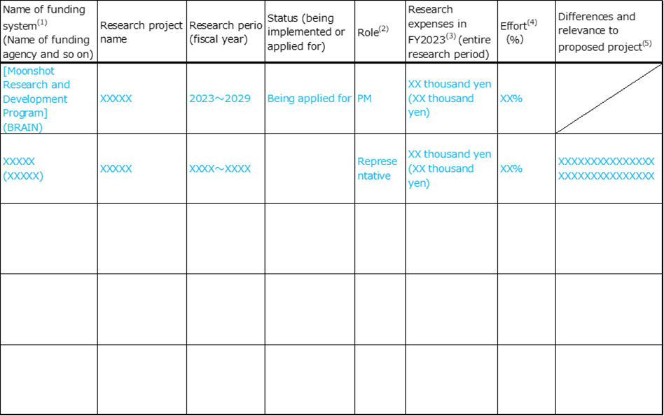

* Please delete the image above that is currently pasted.

Main researchers (*About 3 people or less）　Full name: XX XX

**Copy and paste here the sheet "7-(3)-(i)" in the excel file "Proposal Form"**

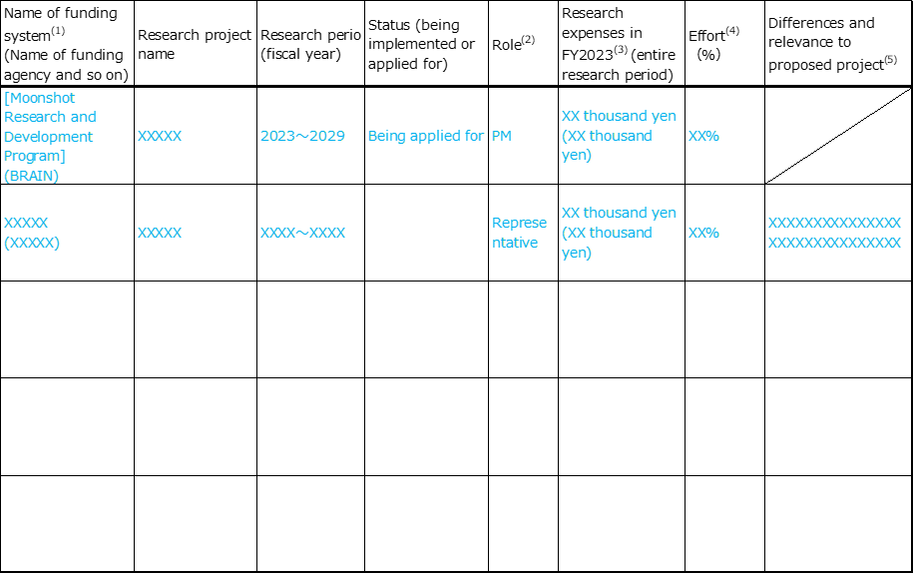

* Please list about three or less main researchers.

(Note 1) Write this proposed project at the top.

(Note 2) If the role of the researcher concerned is the representative or PM of the project, please write "representative (or PM)". Leave blank if they are the main researcher.

(Note 3) Fill in the amount of direct expenses for research funds that the person will receive and use him/herself in 2023 (applied amount if he/she is applying) in the upper row and fill in the total amount that he/she will receive and use him/herself for the entire research period (planned amount) in the lower row in parentheses.

In addition, if the researcher is a sharing co-investigator, and others, fill in the amount of shared fund that he/she will receive and use him/herself in 2023 (planned amount) in the upper row, and fill in the total amount that he/she will receive and use him/herself for the entire research period (planned amount) in the lower row in parentheses. Fill in "0" for each portion if the shared fund is not allocated.

(Note 4) In the case that researcher's total work hours per year (substantial total work hours including not only research activities but also educational activities) is defined as 100%, fill in the allocation rate (%) of the time to be required for implementation of research activities, and so on.

In addition, if this application is adopted, the "effort" at that time will be decided again and registered in e-Rad.

(Note 5) If the project concerned is related to the research content of this proposed project, briefly describe the results or content of that research, and fill in that it can be clearly distinguished from this proposal.

1. Activities to date as a research group

* For this application, if there are your past activities (such as participation in study groups or examination meeting related to industry-academia-government collaboration, achievements in collaborative research with other institutions, and so on) as a research group (it does not need to be the same research implementation system of the proposal research plan), please provide a brief description.

1. Self-financed research and development currently being implemented or planned to be implemented in parallel in the future

* If there is research and development that is currently being carried out with own funds or is scheduled to be carried out with own funds after being commissioned with this project, write that the project plan and accounting that you wish to carry out by being commissioned with this proposed project can be clearly distinguished

1. **Detailed estimate amount of research expenses for each research institution, and others**
2. Budget amount by institution

**Copy and paste here the sheet "7-(4)-(i)" in the excel file "Proposal Form"**

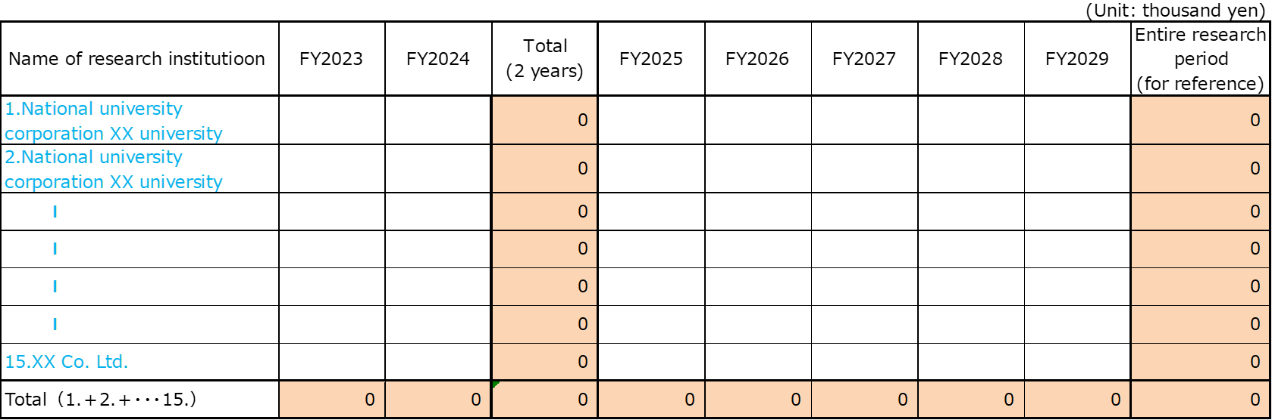

* Please delete the image above that is currently pasted.

1. Breakdown of research expenditures by each fiscal year

<Overall research group>

**Copy and paste here the sheet "7-(4)-(ii) <Overall research group>" in the excel file "Proposal Form"**

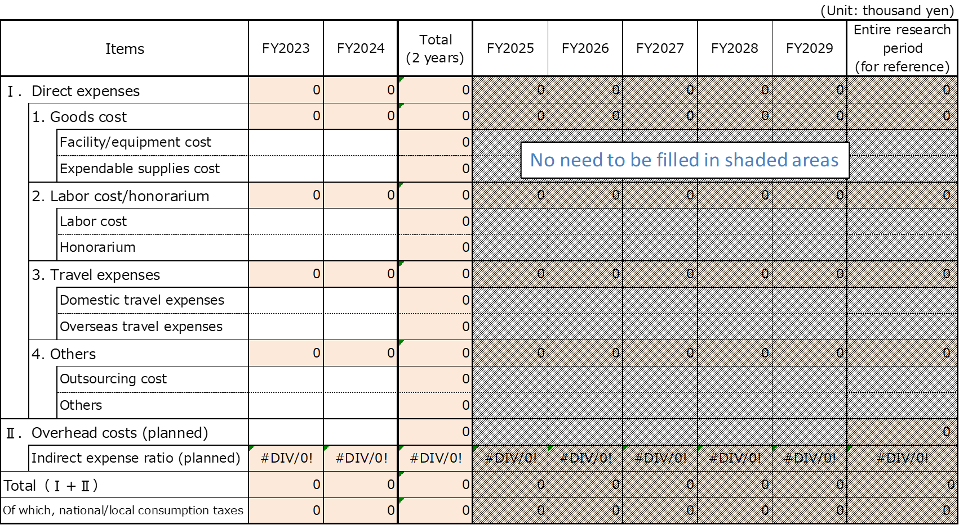

* Please delete the image above that is currently pasted

<Representative organization: XXXX>

**Copy and paste here the sheet "7-(4)-(ii) <By institution>" in the excel file "Proposal Form"**

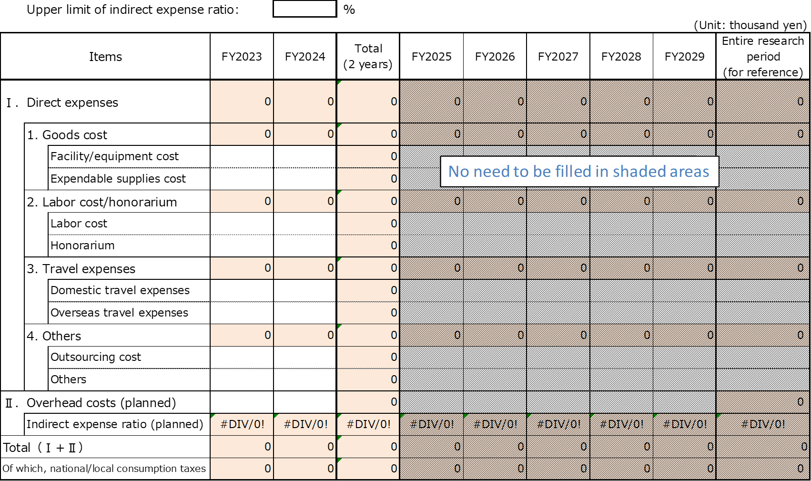

* Please delete the image above that is currently pasted.

<PM activity expenses：XXXX>

* Please fill in the PM's activity expenses (included in the breakdown of research expenses for each fiscal year at the representative institution).

**Copy and paste here the sheet "7-(4)-(ii) <By institution>" in the excel file "Proposal Form"**



* Please delete the image above that is currently pasted.

<Collaborative research institution：XXXX>

* Please add a table for each collaborative research institution for all collaborative research institutions as targets and fill it out.

**Copy and paste here the sheet "7-(4)-(ii) <By institution>" in the excel file "Proposal Form"**



* Please delete the image above that is currently pasted.

1. Breakdown of facilities and equipment costs (FY2023-FY2024)

**Copy and paste here the sheet "7-(4)-(iii)" in the excel file "Proposal Form"**

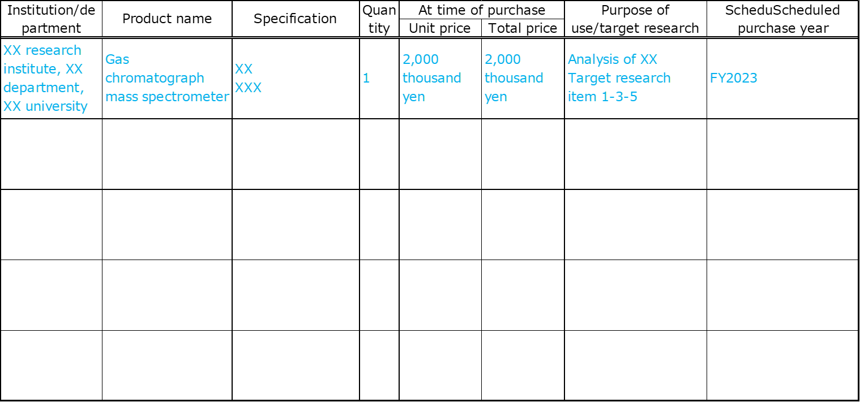

<Consideration notes on filling in>

* Fill in the facilities and equipment costs planned for the two years (2023-2024).

* Please list the goods costing 1 million yen or more out of facilities and equipment costs. In addition, if it is adopted, you shall be asked also to consider the means such as purchasing, leasing, and renting.

* Please insert appropriate rows as necessary.

* In the column of purpose of use, clearly and concisely describe the necessity and purpose of use under this project.

1. Ownership status of facilities and others to be used under this project proposal (FY2023-FY2024)

**Copy and paste here the sheet "7-(4)-(iv)" in the excel file "Proposal Form"**

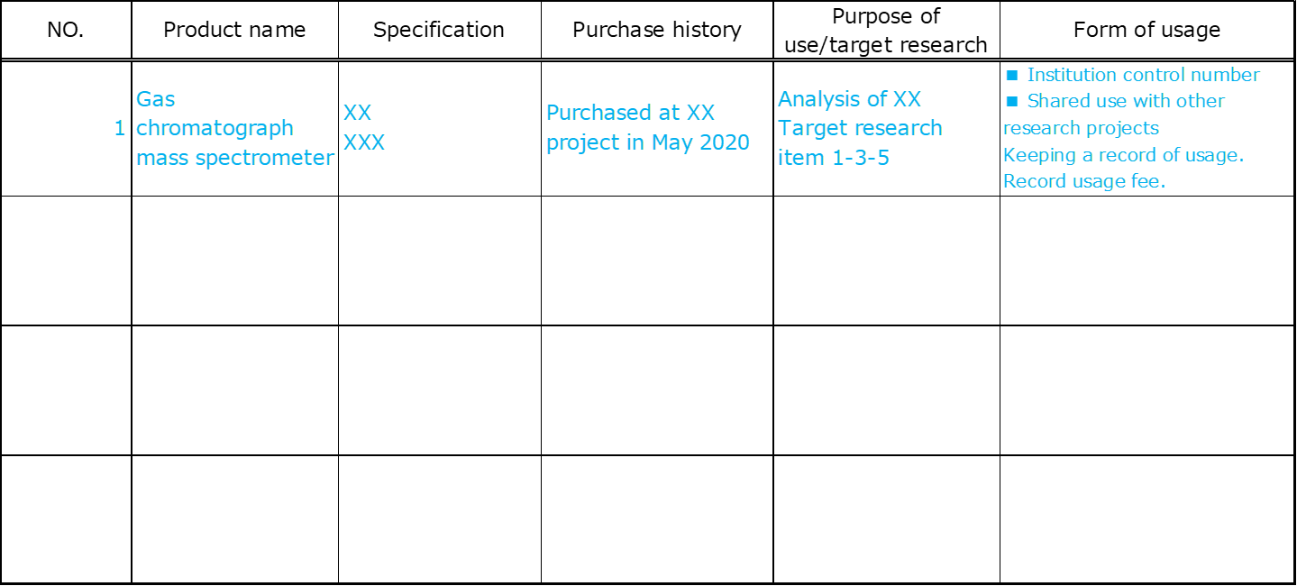

(Note) Please fill in the facilities, and others that you plan to use in the next two years (2023-2024).

1. Breakdown of personnel expenses (FY2023-FY2024)

**Copy and paste here the sheet "7-(4)-(v)" in the excel file "Proposal Form"**

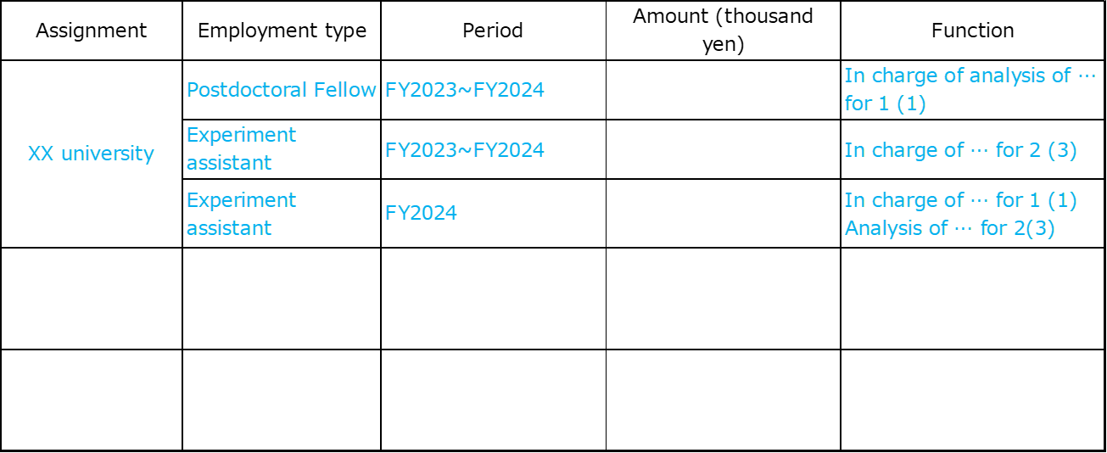

Please fill in the personnel expenses that you plan for the next two years (2023-2024).

* Please insert appropriate rows as necessary.

[(4) Consideration notes regarding preparation of detailed estimate research expenses for each research institution, and others]

1. Please fill in each required amount including consumption tax (10%).

2. Indirect expenses are expenses indirectly required by research institutions, and others in connection with the execution of research, and are expenses to support the implementation of maintenance and operation expenses and others for facilities related to administrative departments, research departments, and other related business departments, and it is an expense other than what should be appropriated as a direct expense. The indirect expense ratio can be recorded up to an amount equivalent to 10% to 30% of the total direct expenses (30% for universities and 10% for private companies (but 20% for small and medium enterprises)). In addition, please calculate the required amount after consulting well with the management department and others in advance.

1. **Information of the participation institutions**

**[Representative organization]**

**Copy and paste here the sheet "8 <Representative organization>" in the excel file "Proposal Form"**



**[Collaborative research institutions]**

**Copy and paste here the sheet "8 <Collaborative research institutions>" in the excel file "Proposal Form"**



**[Cooperating organizations]**

**Copy and paste here the sheet "8 <Cooperating organizations>" in the excel file "Proposal Form"**



**<Precautions when filling in>**

Note *1 The person in charge of supervising and managing the implementation of research and development at the relevant institution. The person may be the same person as the PM in case of representative institution.

Note *2 Person being responsible for accounting, budget, and others of the organization concerned.

Note *3 Person in charge of accounting for this project. The person may be the same person as the general accounting manager in case of representative institution.

*Please fill in the main institution, all collaborative research institutions, and all cooperating organizations.

*The PM and general accounting manager, the research implementation supervisor and accounting manager, and general accounting manager and research implementation supervisor must be different people.

*Please enter your phone number and e-mail address in single-byte characters.

*If there are multiple collaborative research institutions and cooperating organizations, please add forms.

*For financial status, enter the corresponding amount from the financial statements for the most recent three years, and enter the amount on the "balance sheet" and "income statement."

*Regarding local governments, it is not necessary to fill in the financial status.

1. **Situation and so on of efforts of participating institutions for intellectual property In principle, no more than 2 sheets of A4 paper**
2. **Whether each participating institution has a policy regarding the management such as intellectual property policies, and so on**

*This item is aiming for confirming whether each participating institution has established a policy, and others regarding the management of intellectual property, and is managing intellectual property based on that policy, and others. If each participating institution has established a policy, and others regarding the management of intellectual property, please mark in the left column with a circle and enter the details.

* Participating institutions include the representative organization, all collaborative research institutions, and all cooperating institutions.

|  |  |
| --- | --- |
| Existence or Non-existence of a management policy | Details of a policy regarding the intellectual property management such as intellectual property policies, and so on |
| (Entry example)  **○** | (Entry example)  Representative organization XX ”Existence”: XX intellectual property policies  Collaborative research institution XX “Existence”: Policies on intellectual property  Cooperating organization XX “Non-existence” |

1. **Existence or Non-existence of a management system by an intellectual property department, and others at each participating institution**

*This item is aiming for confirming whether each participating institution has the intellectual property management system. If each participating institution has established an intellectual property management system, please mark in the upper row with a circle and enter the details.

|  |  |
| --- | --- |
| Existence or Non-existence of management systems | Details of management systems |
| (Entry example)  **○** | (Entry example 1)  Representative organization XX ”Existence”  Set up an Intellectual Property Department to manage intellectual property in general, and manage it with X people in charge  Collaborative research institution XX ”Existence”  Placement of personnel in charge of intellectual property management, and others in the XX section  Collaborative research institution XX ”Existence”  Centralized management by the head of XX (consult with an external patent attorney, and so on as appropriate)  Cooperating organization XX “Non-existence”  (Entry example 2) |

1. **Licensing of implementing intellectual property　　Required**

* Please fill in if there is a policy to enable broad licensing after acquiring intellectual property from the perspective of further promoting the commercialization by utilizing intellectual property based on research results.

|  |
| --- |
| (Entry example)  Of the research results obtained in this project, we will patent the XXX technology that uses XXX, however, to disseminate this technology widely in each production area, it is planned to be able to license widely after five years after acquiring the intellectual property. |

1. **Accounting work system Required: no more than 2 sheets of A4 paper**

* Please fill in the accounting system of the institution (representative organization) where the accounting manager will be placed. There is no need for the accounting system of collaborative research institutions.

**Existence of the accounting system that enables separate accounting processing**

1. **Do you currently have an accounting system in place that allows for separate accounting processing?**

* Please circle either one.

・Currently in place

・Not currently in place

1. **Its details**

*For institutions that are not currently in place, please also fill in the scheduled date for equipping the system in place (if the preparation is not completed by the time the contract is concluded, the adoption shall be cancelled).

(Entry example) When the system has been in place.

・Since the budget code can be set in the accounting system currently in use, it is possible to separate accounting processing by assigning a new code to the expenses related to this commissioned project.

・Since the accounting system has a mechanism of breakdown book for each fund type, it is possible to perform separate accounting processing.

(Entry example) When the system has not been in place.

・Since the accounting system currently in use cannot handle separate accounting processing, we plan to create a separate breakdown table using spreadsheet software.

　Scheduled time being in place: At the time of adoption decision

・Currently, we do not create a ledger for each received funds, but when we implement this commissioned project, we plan to deal with by preparing a new ledger for this commissioned project.

　Scheduled time being in place: At the time of signing the contract

1. **Participation of young researchers Required**

*Please fill in the table below for the planned number of young researcher’s participation for each institution. This information will be used for the screening of proposals.

|  |  |  |
| --- | --- | --- |
| Name of representative organization and collaborative research institutions | Number of researchers under the age of 40 | Number of researchers aged 41 and over |
| XXX Co., Ltd. | XX | XX |
| XXX University | XX | XX |
|  |  |  |
|  |  |  |
|  |  |  |

(add/delete rows as needed)

(Note) Fill in by age as of April 1, 2023.

1. **Promotion of work-life balance Required**

*If you are legally accredited based on the Act on Promotion of Women's Participation and Advancement in the Workplace, Act on Advancement of Measures to Support Raising Next-Generation Children, Act on Promotion of Youth Employment, i.e., Eruboshi certification, Kurumin certification, Platinum Kurumin certification, and Youth Yell certification, please check the box below and attach a copy of the accreditation notification.

☐ Check box

1. **Conflict of interest Required**
2. **Information about conflicts of interest between PM and PD**

*Please select whether there is a conflict of interest between PM and PD.

If yes, please describe the necessity, rationality, validity, and others of participating in research and development. From the perspective of fair and transparent evaluation, PD who has an interest in the proposer will not participate in the selection process.

In addition, having a conflict of interest means that any of the following (1) to (6) applies.

1. When the PD belongs to the same department (school course, research area, and so on) at the same private company, university, research institution such as a national research and development agency.
2. If the PD has a kinship relationship.
3. When there is a direct competitive relationship with the PD.
4. If the PD has a relationship to conduct close collaborative research with you.
5. If the PD has a close teacher-student relationship or a direct employment relationship with you.
6. In addition, when the Director of BRAIN judges that it is not appropriate to make a fair judgment.

There is a conflict of interest between PM and PD: ☐ Yes ☐ No

*Please select one.

If “yes”, enter one of the numbers i) to vi) that correspond to the interest.

Number:

|  |
| --- |
| Please describe the necessity, rationality, validity, and others of participating in research and development. |

1. **Information about conflicts of interest between PM and research implementation supervisor in collaborative research institutions**

*Please select whether there is a conflict of interest between PM and research implementation supervisor in collaborative research institutions.

If yes, please describe the necessity, rationality, validity, and others of participating in research and development.

In addition, having a conflict of interest means that any of the following (1) to (6) applies.

1. If the research implementation supervisor in collaborative research institutions has a kinship relationship.
2. If the research implementation supervisor in collaborative research institutions has a close teacher-student relationship with you.
3. In addition, when the Director of BRAIN judges that it is not appropriate to make a fair judgment.

Conflict of interest between PM and the research implementation supervisors in collaborative research institutions: ☐ Yes ☐ No

*Please select one.

Conflict of interest of the research implementation supervisors in collaborative research institutions

|  |  |  |  |
| --- | --- | --- | --- |
| Name of researcher | Affiliation | The number corresponding to the conflict of interest | Fill in the necessity, rationality, validity, and others |
|  |  |  |  |
|  |  |  |  |

(Note) Please fill in one of the numbers from i) to iii) above for the number corresponding to the conflict of interest.

1. **A statement of reasons for using a research management administrative body 　Up to 1 sheet of A4 paper, submission required for only applicable research projects**

|  |  |  |  |
| --- | --- | --- | --- |
| Name of project plan |  | | |
| Name of representative organization |  | Name of PM |  |
| Name of research management administrative body |  | Name of manager of research management administrative body |  |

This project shall be allowed, only when BRAIN approves it necessary, to establish apart from the representative organization an institution (referred to hereafter as a “research management administrative body”) for undertaking subcontracted work and carrying out accountancy tasks against BRAIN.

［Examples of cases where a research management administrative body can be established］

・In the case that the PM belongs to a local government and it is admitted as difficult to proceed contracts or other procedures due to special requirements including budgetary measures in advance relating to implementation of research and also it is deemed difficult to assign an accounting manager to the local government.

・In the case that the PM belongs to a small‐to‐medium‐sized enterprise or that multiple small‐to‐medium‐sized enterprises are participating in the research group and they have scarce results of concluding a commissioned contract regarding national competitive research funding system and therefore it is recognized to have a risk of significantly delaying concluding the commissioned contract.

Since this is a special measure, please fill out this form clearly explaining the reason why it is difficult for the representative organization to conclude a commissioned contract with BRAIN.

In addition, when submitting this form, be sure to obtain the approval of the director of finance department, and others of the prefecture or small and medium-sized enterprises, and please fill in the contact information of the person in charge of the finance department (person's name, department, title, telephone number and e-mail address).

In addition, if the project is adopted, we will separately ask you to submit a document stamped with the official seal of the director of finance department of the representative organization.

XX Month XX Day, XX Year

Head of finance of the representative organization

|  |  |
| --- | --- |
| Contact information | |
| Name of the head |  |
| Belonging department |  |
| Position |  |
| Telephone and fax number |  |
| E-mail |  |

(Note) If the project plan is adopted, you will be asked to promptly submit a document stamped with the official seal of the director of finance department of the representative organization.

1. **Consent/Understanding Required**

|  |  |  |  |
| --- | --- | --- | --- |
| Name of project plan |  | | |
| Name of representative organization |  | Name of PM |  |

1. **Understanding of compliance with laws, regulations, guidelines, and others**

It is necessary to comply with given laws and regulation for research activities after adoption. For details, please share information after adoption.

**☐ I will comply with given laws and regulation after adoption.**

(Note) Please refer to 11 “Intellectual property”, 16 “Measures to prevent misuse of research funds”, 18 “Measures to prevent misconduct in research activities”, 23 “Responses to laws, regulations, guidelines, and so on” of the Application guidelines.

1. **Consent on commissioned contract**

*If this proposed project is adopted, if you have no objection to conclude a commissioned contract based on the conditions stated in the commissioned contract (draft) to be presented by BRAIN, please put a check in the box below.

**☐ I have no objection to the consent on the commissioned contract.**

1. **Consent on data management**

* If this proposed project is adopted, based on the matters described in 12 (2) “Data management” of the application guidelines, if there is no objection to the appropriate management and disclosure of data obtained from research and development, please put a check in the box below.

**☐ I have no objection to the agreement on data management.**